A small but architecturally rich microservices project is much better because you can demonstrate Java 8, Spring Boot, REST, JPA, Kafka, security, Docker, AWS, CI/CD, resilience, testing, and system-design decisions.

Recommended project: Order & Inventory Management System
Build a small backend with 3–4 microservices.
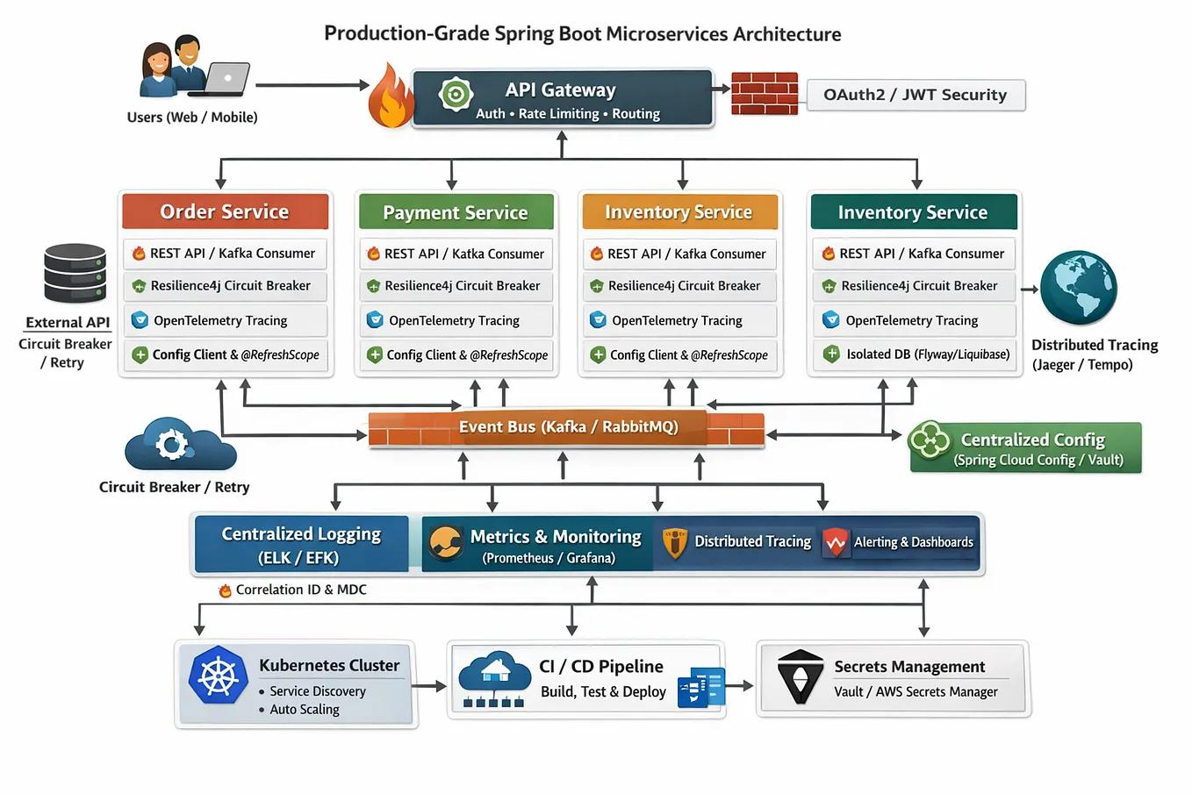
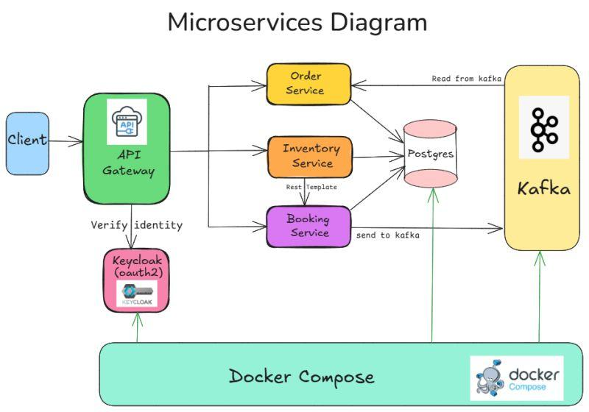
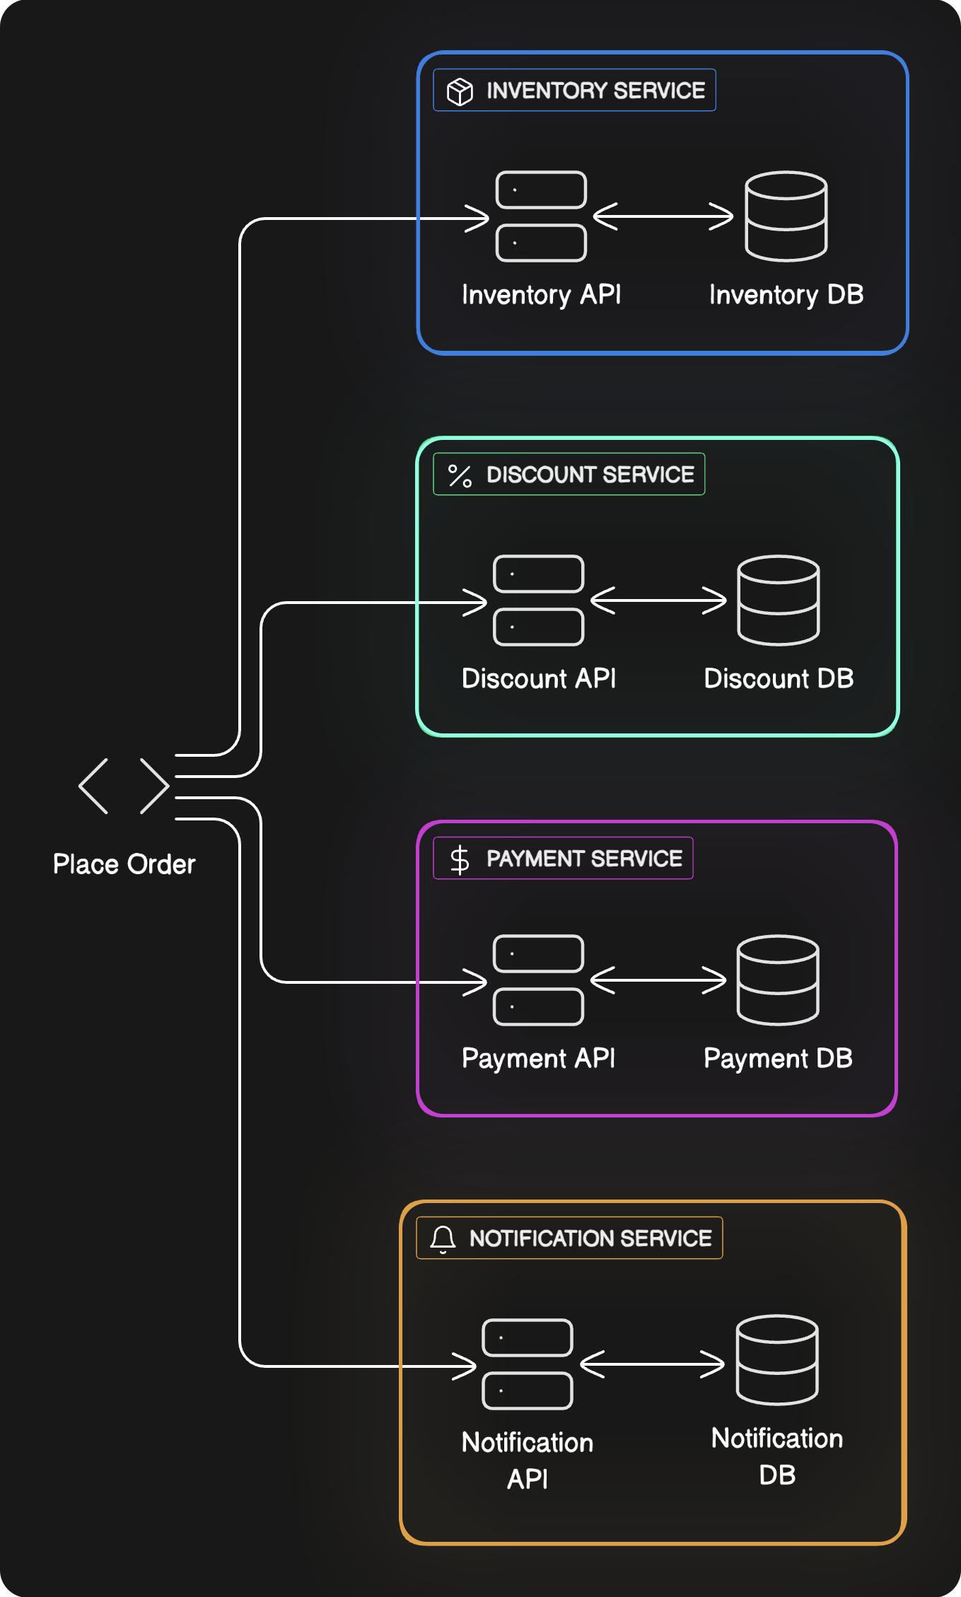
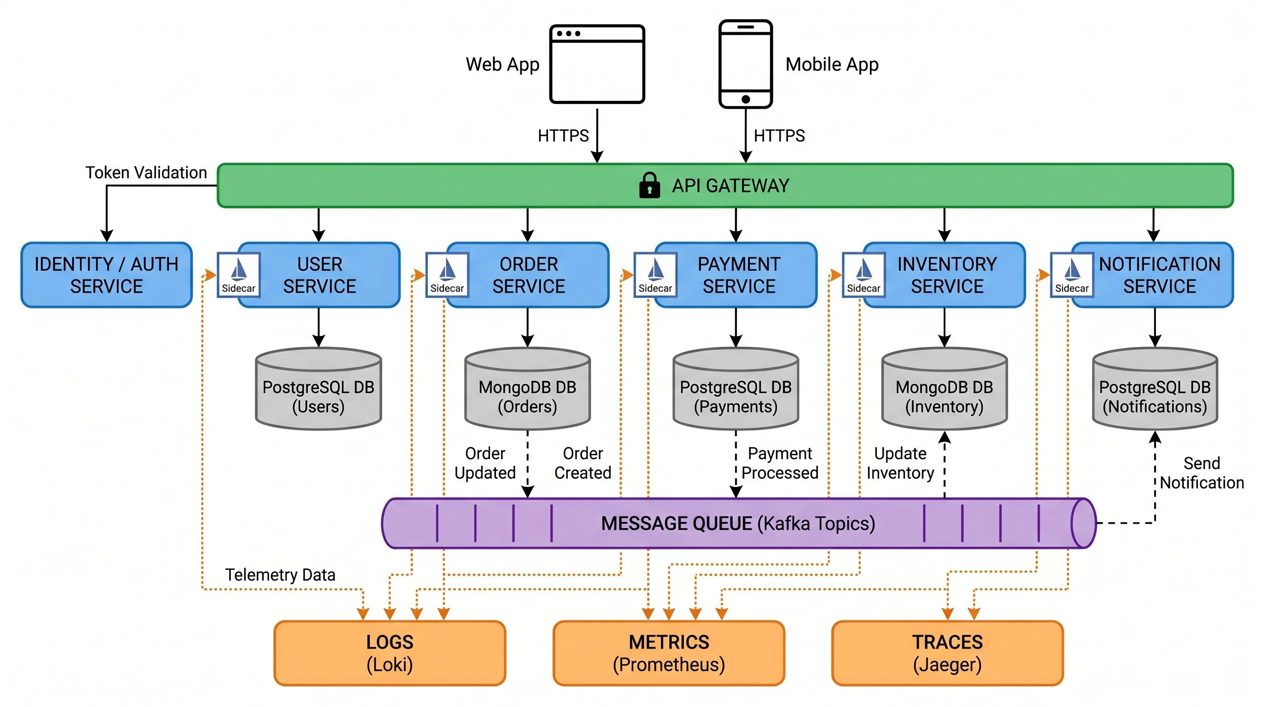
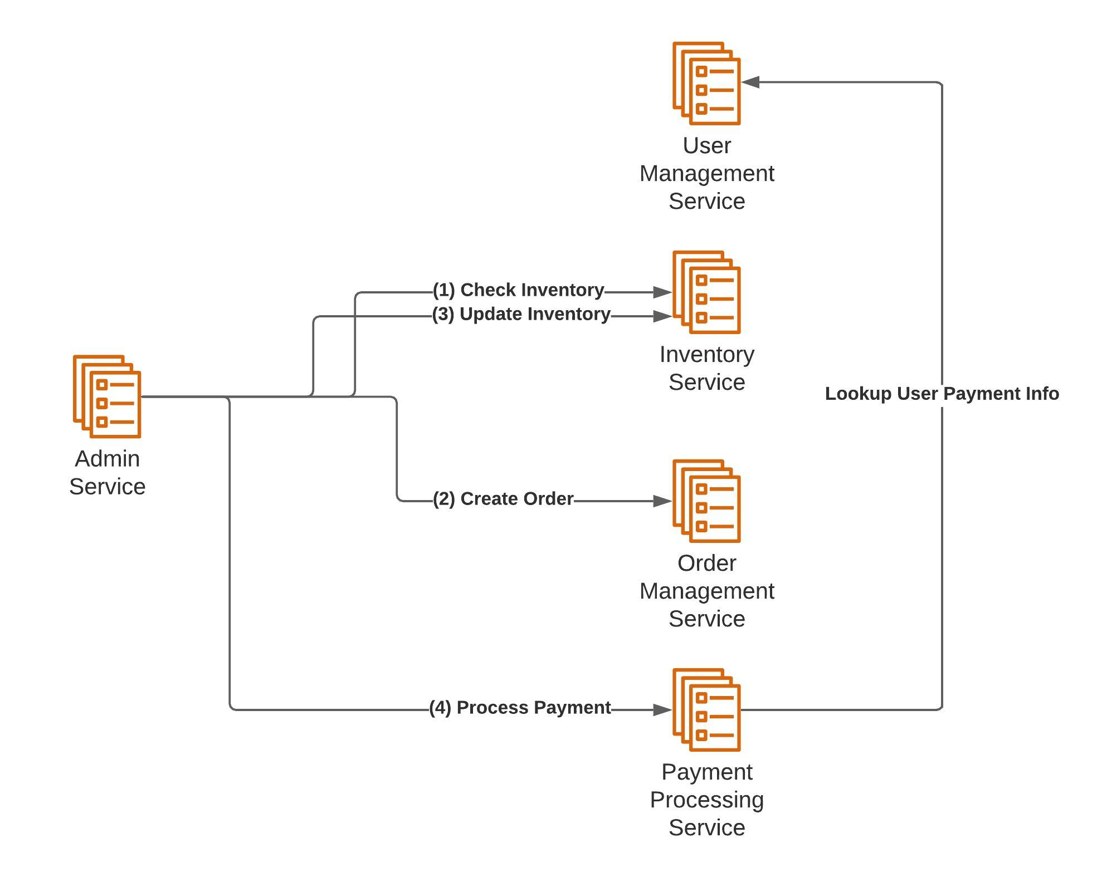
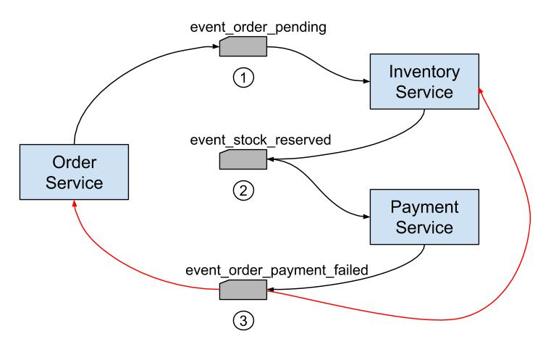
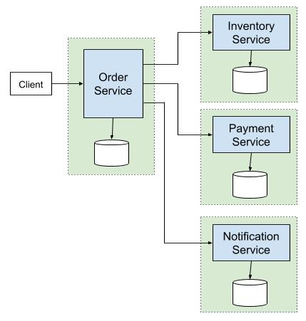

1. Microservices
Service | Main responsibility | Interview concepts
Order Service | Create/manage orders | REST, JPA, transactions, validation
Inventory Service | Check/reserve/release stock | concurrency, locking, transactions
Payment Service | Simulate payment | REST, exception handling, idempotency
Notification Service | Send order notifications | Kafka, async processing
You can initially implement only Order + Inventory + Payment, then add Notification if you have time.

2. Simple business flow
Example:
Client
|
v
API Gateway
|
+----> Order Service
| |
| +----> Inventory Service
| |
| +----> Payment Service
|
+----> Inventory Service
When a customer places an order:
POST /orders

|
v
Order Service
|
| 1. Reserve stock
v
Inventory Service
|
| 2. Stock available
v
Order Service
|
| 3. Process payment
v
Payment Service
|
| 4. Payment successful
v
Order = CONFIRMED
If payment fails:
Payment Failed
|
v
Order = PAYMENT_FAILED
|
v
Release Inventory
This gives you several excellent interview discussions without requiring a huge application.

3. Features I recommend
Keep the actual business functionality small.

Order Service
POST /orders
GET /orders/{id}
GET /orders?customerId=100
PUT /orders/{id}/cancel
Order:
Order
├── id
├── customerId
├── status
├── totalAmount
├── createdAt
└── items
├── productId
├── quantity
└── price
Order states:
CREATED
|
v
INVENTORY_RESERVED
|
v
PAYMENT_PENDING
|
v
CONFIRMED
Failure:
PAYMENT_FAILED
CANCELLED

4. Inventory Service
APIs:
GET /inventory/{productId}

POST /inventory/reserve

POST /inventory/release
Example:
{
"productId": 101,
"quantity": 2
}
This service is particularly useful for a Lead-level interview because you can discuss:
- Optimistic locking
- Pessimistic locking
- Concurrent requests
- Race conditions
- Database transactions
- Idempotency
- Handling insufficient inventory
For example:
@Entity
public class Inventory {

@Id
private Long productId;

private Integer availableQuantity;

@Version
private Long version;
}
Then explain why @Version is useful when two orders try to purchase the last item simultaneously.

5. Payment Service
Don't build a real payment integration.
Just simulate:
POST /payments
Request:
{
"orderId": 1001,
"amount": 2500
}
Response:
{
"paymentId": "PAY-12345",
"status": "SUCCESS"
}
You can deliberately make some transactions fail.
This lets you discuss:
- Timeout
- Retry
- Idempotency
- Circuit breaker
- Distributed transactions
- Failure handling

6. Add Kafka
This is one of the most valuable additions for your interview.
Instead of:
Order Service
|
| REST
v
Notification Service
use:
Order Service
|
| OrderCreated
v
Kafka
|
+----> Notification Service
|
+----> Analytics Service
Events:
OrderCreated
PaymentCompleted
PaymentFailed
OrderCancelled
Example event:
{
"eventType": "ORDER_CREATED",
"orderId": 1001,
"customerId": 2001,
"amount": 2500
}
Now you can discuss:
- Synchronous vs asynchronous communication
- Kafka partitions
- Consumer groups
- Offset
- At-least-once delivery
- Duplicate events
- Idempotent consumers
- Dead-letter topics
That's excellent material for a 7+ year interview.

7. Add API Gateway
Architecture:
Client
|
v
API Gateway
|
+-----------+-----------+
| | |
v v v
Order Inventory Payment
Service Service Service
Gateway responsibilities:
- Routing
- Authentication
- Request logging
- Rate limiting (optional)
You can explain why clients shouldn't directly communicate with every microservice.

8. Add authentication
Keep it simple.
Client
|
| JWT
v
API Gateway
|
v
Microservices
Roles:
CUSTOMER
ADMIN
Example:
CUSTOMER
|
+-- Create Order
+-- View Order
+-- Cancel Order

ADMIN
|
+-- Add Inventory
+-- Update Inventory
This gives you Spring Security/JWT questions.

9. Database design
Don't use one database schema for everything.
Use:
Order Service
|
+-- order_db

Inventory Service
|
+-- inventory_db

Payment Service
|
+-- payment_db
You can use MySQL/PostgreSQL.
Then be ready for:
Why does each microservice have its own database?
Answer:
Because each service should own its data and business logic, reducing tight coupling and allowing independent deployment/scaling.

10. Add Resilience
This is particularly important for a Lead interview.
Imagine:
Order Service
|
v
Payment Service
|
X
DOWN
Without resilience, Order Service could keep waiting.
Implement:
Timeout
Retry
Circuit Breaker
Fallback
For example:
Order
|
+-- Payment Service
|
+-- Timeout
|
+-- Retry
|
+-- Circuit Breaker
Then prepare questions like:
When should you retry?
Why shouldn't every exception be retried?
What happens when Payment Service is unavailable?
What is the difference between timeout and circuit breaker?

11. Distributed transaction
This project gives you a fantastic interview topic.
Suppose:
Order created
|
v
Inventory reserved
|
v
Payment failed
You cannot simply use:
@Transactional
across three independent databases.
Instead, discuss the Saga pattern.
Example:
Create Order
|
v
Reserve Inventory
|
v
Process Payment
|
X
Payment Failed
|
v
Release Inventory
|
v
Cancel Order
This is a very good 7+ year system-design discussion.

12. Testing
Don't skip this.
Create:

Unit tests
JUnit 5
Mockito
Test:
OrderService
InventoryService
PaymentService

Integration tests
Test:
Controller
|
Service
|
Repository
|
Database

API testing
Use:
Postman
or automated integration testing.
You can discuss the difference between:
Unit Test
Integration Test
Contract Test
End-to-End Test

13. Docker
Create:
docker-compose.yml
with:
order-service
inventory-service
payment-service
kafka
zookeeper / kafka dependency
mysql
Example:
Docker
------------------------------------------------
| |
| API Gateway |
| Order Service |
| Inventory Service |
| Payment Service |
| Kafka |
| MySQL |
------------------------------------------------
This gives you Docker interview material.

14. CI/CD
Since you're targeting a Lead role, add a simple Jenkins pipeline:
Git Push
|
v
Jenkins
|
+--> Compile
|
+--> Unit Test
|
+--> Code Quality
|
+--> Build Docker Image
|
+--> Deploy
Even if you don't actually deploy to production, being able to explain the pipeline is valuable.

15. AWS
Since you already work with AWS, make a small deployment:
AWS
|
+------+------+
| |
EC2 S3
|
Docker containers
|
+------+------+------+
| | | |
Order Inventory Payment Kafka
You don't need to implement every AWS service.
Use:
- EC2
- S3
- CloudWatch
- IAM
- RDS — optional

16. Recommended technology stack
For your specific project, I would use:
Java 8
Spring Boot 2.5.x
Spring Data JPA
Spring Security
JWT
REST
MySQL/PostgreSQL
Kafka
JUnit 5
Mockito
Docker
Jenkins
AWS EC2
AWS S3
CloudWatch
Git
And optionally:
Resilience4j
Swagger/OpenAPI
Redis
SonarQube
React JS for Frontend (separate application)

17. Suggested project structure
For example:
order-management-system/
│
├── api-gateway/
│
├── order-service/
│ ├── controller/
│ ├── service/
│ ├── repository/
│ ├── entity/
│ ├── dto/
│ ├── exception/
│ ├── kafka/
│ └── config/
│
├── inventory-service/
│ ├── controller/
│ ├── service/
│ ├── repository/
│ ├── entity/
│ ├── dto/
│ └── exception/
│
├── payment-service/
│ ├── controller/
│ ├── service/
│ ├── repository/
│ └── entity/
│
├── notification-service/
│ ├── consumer/
│ └── service/
│
├── docker-compose.yml
│
├── Jenkinsfile
│
└── README.md

18. Most important part: interview topics
The project itself is only half the preparation.

Java 8
Its good to have these coding best practices in the code :
Lambda
Stream API
Optional
Functional Interface
Method Reference
Default/Static Interface methods
CompletableFuture
ConcurrentHashMap
HashMap internals
equals/hashCode
Immutable objects
Exception handling
Multithreading
ExecutorService

Spring Boot
Dependency Injection
IoC
Bean lifecycle
@Transaction
Spring Security
REST
Exception handling
Validation
Profiles
Actuator
Configuration

Microservices
Service discovery
API Gateway
Synchronous communication
Asynchronous communication
Kafka
Circuit breaker
Retry
Timeout
Idempotency
Saga
Distributed transaction
Database per service
Eventual consistency

Database
Index
Composite index
Transaction isolation
Deadlock
Optimistic locking
Pessimistic locking
N+1 problem
Pagination
Query optimization

Architecture
SOLID
Design patterns
Clean architecture
DDD basics
Scalability
Availability
Consistency
Caching
CAP theorem
Load balancing
Horizontal scaling

My recommended implementation order
Don't try to build everything at once.
PHASE 1 (separate spring application)
Java 8 + Spring Boot
↓
Order Service
↓
Inventory Service
↓
REST communication
PHASE 2(separate spring application)
Payment Service
↓
Exception handling
↓
Transactions
↓
Optimistic locking
PHASE 3(separate spring application)
Kafka
↓
Events
↓
Notification Service
↓
Idempotency
PHASE 4 (separate spring application)
API Gateway
↓
JWT Security
↓
Resilience4j
PHASE 5 (add these coding standdards in each application including docker file)
JUnit + Mockito
↓
Docker
↓
Jenkins (just create a jenkin pipeline)
↓
AWS deployment
PHASE 6 (Create a ReactJS application and integrate all the API endpoints into it) hndle circuit breaking in case of any failuer of any services .

The final architecture you should be able to draw in an interview
CLIENT
|
v
+-------------+
| API Gateway |
+-------------+
|
+-------------+-------------+
| | |
v v v
+----------+ +----------+ +----------+
| Order | |Inventory | | Payment |
| Service | | Service | | Service |
+----+-----+ +----------+ +----------+
|
| Events
v
+--------+
| Kafka |
+---+----+
|
v
+----------------+
| Notification |
| Service |
+----------------+

| | |
v v v
Order DB Inventory DB Payment DB

AWS / Docker / Jenkins
|
v
CI/CD Pipeline

